A MINI PROJECT REPORT
ON
Smart Industrial Safety Helmet
Submitted in partial fulfillment of the requirements for the
Award of the Degree
Of

BACHELOR OF TECHNOLOGY
In
ELECTRONICS AND COMMUNICATION ENGINEERING

By
Mamindla Revathi 23C31A0495
Kalvacherla Pranay 24C35A0410
Naraboina Naveen 23C31A04C1
Mavurapu Vishnu Vardan 24C35A0415
Paidipala Ashvitha 23C31A04C9

Under the guidance of
Mr.D.Prasad

Assistant Professor
Dept. of ECE

DEPARTMENT OF ELECTRONICS AND COMMUNICATION ENGINEERING BALAJI INSTITUTE OF TECHNOLOGY & SCIENCE (AUTONOMOUS) Accredited by NBA, NAAC A+ & ISO 9001:2015 Certified Institution (Affiliated to JNTUH, Hyderabad and Approved by the AICTE, New Delhi) NARSAMPET, WARANGAL 506 331
2026– 2027

BALAJI INSTITUTE OF TECHNOLOGY & SCIENCE (AUTONOMOUS)

Accredited by NBA, NAAC A+&ISO 9001:2015 Certified Institution (Affiliated to JNTUH,
Hyderabad and Approved by the AICTE, New Delhi)
Laknepally, Narsampet, Warangal - 506 331

DEPARTMENT OF ELECTRONICS & COMMUNICATION ENGINEERING


CERTIFICATE
This is to certify that this Project Work entitled “Smart Industrial Safety Helmet" is a bonafide work carried out Mamindla Revathi (23C31A0495), Kalvacherla Pranay (24C35A0410), Naraboina Naveen (23C31A04C1), Mavurapu Vishnu Vardan (24C35A0415), Paidipala Ashvitha (23C31A04C9) in partial fulfilment of the requirements for the award of the degree of Bachlor of Technology from JNTUH,Hyderabad during the period 2026-2027 under our guidance and supervision.

Internal Guide Head Of Dept.

Mr.D.Prasad Dr.P.Kiran Kumar
Assistant Professor Associate Professor
Dept. of ECE Dept. of ECE

External Examiner

DECLARATION
We , Mamindla Revathi (23C1A0495) , Kalvacherla Pranay (24C35A0410) ,Naraboina Naveen (23C31A04C1) ,Mavurapu Vishnu Vardan (24C35A0415) and Paidipala Ahsvitha (23C31A04C9),hereby declare that the project entitled “Smart Industrial Safety Helmet" submitted in the partial fulfillment of the requirements for the award of B.Tech in Electronics and Communication Engineering to Balaji Institute of Technology & Science, Narsampet, affiliated to JNTUH, Hyderabad is a authentic work and has not been submitted to any other university or institution for award of the degree.

Mamindla Revathi 23C31A095

Kalvacherla Pranay 24C35A0410
Naraboina Naveen 23C31A04C1
Mavurapu Vishnu Vardan 24C35A0415
Paidipala Ashvitha 23C31A04C9

ACKNOWLEDGEMENT
It is a great pleasure to express our deepest sense of gratitude and indebtedness, to our Internal guide Mr.D.Prasad, Associate Professor,Head of Dept., of ECE, BITS, Narsampet, for having been a source of constant inspiration, precious guidance and generous assistance during the project work. We deem it as a privilege to have worked under her able guidance. Without her close monitoring and valuable suggestions this work wouldn’t have taken this shape. We feel that this help is un-substitutable and unforgettable.
We wish to express our sincere thanks to Dr. V. S.Hariharan, Principal, BITS, Narsampet for providing the college facilities for the completion of the project.
We are profoundly thankful to Dr.P.Kiran Kumar, Head of ECE Dept, for his cooperation and encouragement.
We are greatly thankful to our Project coordinator Dr.V.Madhu Kumar, Assoc. Prof., Dept. of ECE, BITS, Narsampet for his support throughout our project.
Finally, we thank all the faculty members, supporting staff of ECE Dept. and friends for their kind co-operation and valuable help for completing the project.

Mamindla Revathi 23C31A0495
Kalvacherla Prnay 24C35A0410
Naraboina Naveen 23C31A04C1
Mavurapu Vishnu Vardan 24C35A0415
Padipala Ashwitha 23C31A04C9

Abstract
The Smart Industrial Safety Helmet is an intelligent wearable designed to significantly enhance worker safety in hazardous industrial environments such as manufacturing plants, construction sites, and mining operations. Traditional helmets offer only passive protection against head injuries, whereas this smart helmet incorporates a suite of advanced sensors and IoT (Internet of Things) technologies to actively monitor environmental and worker conditions in real time. Key integrated sensors include gas detectors for identifying harmful or explosive gases, temperature and humidity sensors to detect unsafe environmental conditions, accelerometers and IMUs for fall and impact detection, and GPS modules for location tracking. When a potential hazard is detected—such as gas leakage, overheating, accidental falls, or prolonged exposure to dangerous conditions. the system generates immediate alerts to the wearer through onboard indicators and communicates data wirelessly to a centralized monitoring system for rapid supervisory response. The helmet’s connectivity supports cloud-based dashboards, enabling remote monitoring, historical data analysis, and timely decision-making for safety managers. By combining real-time hazard detection, worker tracking, and automated alert systems within a single wearable unit, the Smart Industrial Safety Helmet aims to reduce workplace accidents, improve emergency responsiveness, and foster safer industrial operations.

LIST OF FIGURES
FIGURE NO: | TITLE | PAGE NO:
2.1 | Block diagram | 24
2.2 | Circuit daigram | 31
4.1 | Liquid crystal display | 33
4.2 | Light Emitting diode | 34
4.3 | Battery | 34
4.4 | Arduino uno | 35
4.5 | Jumper Wires | 36
4.6 | Light dependent resistor Sensor | 37
4.7 | Universal serial bus cable | 38

CONTENTS
Declaration i
Acknowledgement ii
Abstract iii
List of Figures iv

CHAPTER NO DESCRIPTION PAGENO PAGENO
CHAPTER 1 INTRODUCTION
1.1 Overview 1
1.2 Problem Statement 5
1.3 Objective 9
1.4 Existing System 10
1.5 Proposed System 11
CHAPTER2 Literatire Survey 14

CHAPTER3 PROPOED METHODOLGY
3.1 Block Diagram 17
3.2 Working Principle 19
3.3Architecture 22
CHAPTER 4 HARDWARE COMPONENTS
4.1 Ardunio UNO/ESP32
4.2 Gas Sensor
4.3 Temperature Sensor
4.4 Accelerometer(ADXL335)
4.5 Bluetooth
4.6 Power Supply
4.7 Buzzer SOFTWARECOMPONENTS
4.8UsingOfflineIDE2.x

CHAPTER 5 Results &Analysis
CHAPTER 6 APPLICATIONS
ADVANTAGESANDDISADVANTAGES
CONCLUSION
CHAPTER 7 FUTURESCOPE
CHAPTER 8 REFERNCES

CHAPTER 1 INTRODUCTION
1.1 OVERVIEW:
1

An industrial safety helmet is a protective headgear worn by workers in hazardous environments such as construction sites, factories, and mines. It is an essential part of Personal Protective Equipment (PPE) designed to reduce the risk of head injuries caused by falling objects, collisions, or electrical hazards.
The helmet consists of a hard outer shell made from durable materials like high-density plastic, which provides resistance against impact and penetration. Inside the helmet, a suspension system (a network of straps) creates a gap between the head and the shell, helping to absorb shock and distribute the force of impact. A chin strap is often included to keep the helmet securely in place during movement or sudden incidents.
In modern industries, smart safety helmets are also used. These advanced helmets are integrated with electronic components such as sensors and communication modules. They can detect harmful gases, monitor temperature, and identify sudden falls or accidents. When a dangerous situation is detected, the system can alert the worker through alarms and send emergency notifications to supervisors.
Overall, an industrial safety helmet not only provides basic physical protection but, in its smart form, also enhances workplace safety by enabling real-time monitoring and quick response to hazards.
An industrial safety helmet is a critical safety device used to protect workers from head injuries in hazardous environments. It is specially designed to withstand impact, resist penetration, and in some cases provide insulation against electrical hazards. These helmets are widely used in industries such as construction, mining, manufacturing, and oil & gas.
An industrial safety helmet is an essential protective device worn by workers in hazardous environments such as construction sites, factories, mining areas, and oil & gas industries. It is a key component of Personal Protective Equipment (PPE) and plays a vital role in preventing head injuries caused by accidents and unsafe working conditions.
The human head is one of the most sensitive parts of the body, and even a minor injury can lead to serious consequences. In industrial environments, risks such as falling objects, collisions with machinery, slips and falls, and exposure to electrical hazards are very common. To reduce these risks, safety helmets are designed to provide a protective barrier between the worker’s head and potential dangers.
A traditional safety helmet, commonly known as a hard hat, is made from strong materials like High-Density Polyethylene (HDPE) or Acrylonitrile Butadiene Styrene (ABS). These materials are chosen for their durability, lightweight nature, and ability to absorb impact. The helmet is designed not only to protect but also to ensure comfort for long working hours.
In recent years, technological advancements have led to the development of smart industrial safety helmets, which integrate sensors and communication systems. These helmets go beyond basic protection by monitoring environmental conditions and providing real-time alerts, making workplaces safer and more efficient.

1.2 PROBLEM STATEMENT:
In industrial environments such as construction sites, mining areas, and manufacturing units, worker safety is a major concern due to the presence of hazardous conditions. Workers are frequently exposed to risks such as falling objects, toxic gas leakage, extreme temperatures, and accidental falls. Although industrial safety helmets are widely used as protective equipment, they provide only basic physical protection and are not capable of identifying or responding to dangerous situations.
Traditional helmets function as passive devices, meaning they can reduce the impact of injuries but cannot prevent accidents or provide warnings before a hazardous event occurs. For example, in the case of toxic gas exposure, a worker may not be aware of the danger until it is too late. Similarly, during sudden falls or accidents, there is no automatic system to detect the incident and inform supervisors or emergency services. This lack of real-time monitoring and communication significantly increases the risk of serious injuries and fatalities.
Another major issue is the absence of immediate alert mechanisms. In many industrial settings, workers operate in isolated or noisy environments where manual communication is difficult. If an emergency occurs, delays in reporting can lead to severe consequences. Additionally, extreme environmental conditions such as high temperature and humidity can affect the health and efficiency of workers, yet traditional helmets do not provide any means to monitor these parameters.
Therefore, the existing safety systems are insufficient to ensure complete protection for industrial workers. There is a strong need for an advanced solution that not only protects the worker’s head but also actively monitors environmental conditions and detects accidents. This leads to the development of a smart industrial safety helmet, which integrates sensors and communication technologies to provide real-time monitoring, instant alerts, and improved safety measures. Such a system can significantly reduce workplace accidents, enhance response time during emergencies, and create a safer working environment.

In modern industrial environments, ensuring worker safety remains a significant challenge despite the availability of basic protective equipment. Industries such as construction, mining, oil and gas, and manufacturing involve complex operations where workers are continuously exposed to hazardous conditions. These hazards include falling objects, exposure to toxic gases, extreme temperatures, electrical risks, and accidental falls. While safety helmets are mandatory in such environments, their functionality is limited to passive protection, which is not sufficient to handle the dynamic and unpredictable nature of industrial risks.
One of the major problems is the inability to detect environmental hazards in real time. Toxic gases such as carbon monoxide, methane, or other harmful chemicals may leak without any visible signs, posing serious health risks to workers. Traditional helmets cannot sense these conditions, leaving workers unaware of potential dangers until symptoms appear. Similarly, high-temperature environments can lead to heat stress, dehydration, or even burns, yet there is no mechanism in conventional helmets to monitor or alert workers about unsafe temperature levels.
Another critical issue is the lack of accident detection and response systems. Industrial workers are prone to slips, trips, and falls, especially in uneven or slippery working conditions. In many cases, if a worker falls unconscious, there is no immediate way to notify supervisors or emergency services. This delay in response can worsen injuries and, in extreme cases, lead to loss of life. The absence of automatic fall detection and alert systems highlights a major gap in existing safety measures.
Furthermore, communication barriers in industrial settings add to the problem. Workers often operate in noisy environments or remote locations where it is difficult to communicate emergencies effectively. Manual reporting methods are unreliable and time-consuming, especially during critical situations. This results in delayed rescue operations and increased risk.
Another limitation is the lack of integration between safety equipment and monitoring systems. Current safety practices rely heavily on manual supervision and periodic inspections, which are not always effective. There is no continuous tracking of worker conditions or environmental parameters, making it difficult to prevent accidents proactively.
In addition, human factors such as negligence, lack of awareness, or improper use of safety equipment contribute to accidents. Workers may ignore warning signs or fail to follow safety protocols due to workload or fatigue. Without an intelligent system to assist and alert them, the chances of accidents increase significantly.
Therefore, the existing industrial safety approach is reactive rather than proactive. It focuses on minimizing damage after an accident rather than preventing it. This creates a strong need for a smart and automated safety solution that can continuously monitor the worker and the environment.
The proposed solution is the development of a Smart Industrial Safety Helmet, which integrates advanced technologies such as sensors, microcontrollers, and communication modules. This helmet can detect harmful gases, monitor temperature, identify falls or unusual movements, and send real-time alerts to supervisors or emergency contacts. By providing immediate warnings and enabling quick response, the system can significantly reduce the severity of accidents.
In conclusion, the major problem in industrial safety lies in the lack of real-time monitoring, delayed communication, and absence of intelligent detection systems. Traditional helmets alone cannot address these challenges. Hence, an advanced smart helmet system is essential to enhance worker safety, improve emergency response, and create a more secure industrial environment.

Challenges Faced by People:
Workers in industrial environments face numerous challenges that directly impact their safety, health, and overall productivity. These challenges arise due to the presence of hazardous conditions, heavy machinery, and the lack of advanced monitoring systems. Despite the use of protective equipment like helmets, many risks still remain unaddressed.
One of the primary challenges is exposure to hazardous gases and harmful substances. In industries such as mining, chemical plants, and oil refineries, workers may unknowingly inhale toxic gases like carbon monoxide or methane. These gases are often colorless and odorless, making them difficult to detect without specialized equipment. Continuous exposure can lead to serious health problems, unconsciousness, or even death.
Another significant issue is extreme temperature conditions. Many industrial processes involve high heat, which can cause heat stress, dehydration, and fatigue among workers. Prolonged exposure to such environments reduces concentration levels and increases the likelihood of mistakes and accidents. Traditional safety gear does not provide any mechanism to monitor or warn workers about unsafe temperature levels.
Accidents and physical injuries are also common challenges in industrial settings. Workers frequently operate in risky conditions involving heights, heavy equipment, and slippery surfaces. Falls, collisions, and being struck by objects can result in severe injuries, particularly head injuries. Although helmets provide some protection, they cannot prevent accidents or detect when an incident occurs.
In addition, lack of real-time monitoring and alert systems makes the situation more critical. Most industries rely on manual supervision, which is not always effective in identifying dangers immediately. If an accident occurs, there is often a delay in response due to the absence of automatic detection and communication systems. This delay can worsen the condition of the injured worker.
Communication barriers further complicate safety management. Industrial environments are usually noisy, and workers may be spread across large or remote areas. In such situations, it becomes difficult to quickly inform others about emergencies. The inability to communicate effectively can delay rescue operations and increase risks.
Another challenge is physical fatigue and mental stress caused by long working hours and demanding tasks. Fatigue reduces alertness and decision-making ability, which can lead to human errors. Workers under stress are more likely to overlook safety precautions, increasing the chances of accidents.
Moreover, electrical hazards pose a serious threat, especially for workers dealing with electrical equipment. Without proper insulation and safety measures, there is a high risk of electric shocks and burns. Not all safety helmets are designed to provide adequate electrical protection.
Finally, lack of awareness and improper use of safety equipment contribute to workplace accidents. Some workers may not be fully trained or may neglect safety protocols due to workload or negligence. Traditional helmets, while useful, have limitations as they only provide passive protection and lack advanced features to handle modern industrial challenges.
In conclusion, workers in industrial environments face multiple interconnected challenges, including hazardous exposure, physical risks, communication issues, and lack of advanced safety systems. Addressing these challenges requires the adoption of smart and intelligent safety solutions that can monitor conditions in real time, provide alerts, and improve overall workplace safety.

1.3 OBJECTIVES:
- To protect the worker’s head from injuries
- To detect harmful and toxic gases in the environment
- To monitor temperature levels continuously
- To detect falls and accidents using sensors
- To provide instant alerts using buzzer or LED
- To send emergency messages through GSM or WiFi
- To reduce response time during accidents
- To improve overall worker safety and efficiency
- To minimize industrial accidents and risks
- To develop a low-cost and reliable safety system
The objectives of a smart industrial safety helmet focus on improving worker safety by combining traditional protection with modern technology. The aim is to create a system that not only protects the head but also monitors environmental conditions and responds to dangerous situations in real time.
The main objective is to enhance worker safety in hazardous environments such as construction sites, mining areas, and factories. The helmet is designed to reduce risks by providing both physical protection and intelligent monitoring features.
Another objective is to detect harmful gases present in the environment. By using gas sensors, the system continuously checks air quality and alerts the worker when toxic or flammable gases are detected, helping to prevent serious health issues.
The system also aims to monitor temperature conditions. High temperatures can lead to heat stress and fatigue, so the helmet provides warnings when the temperature exceeds safe limits, allowing workers to take necessary precautions.
An important objective is to detect accidents such as falls or sudden impacts. With the help of an accelerometer, the helmet can identify abnormal movements and trigger alerts, ensuring quick assistance in case of emergencies.
The helmet is also designed to enable real-time communication. Using GSM or WiFi modules, it can send emergency messages to supervisors or control rooms, reducing response time and improving safety.
Another objective is to provide immediate warning signals through buzzers or LED indicators. These alerts help workers respond quickly to dangerous situations.
The system also aims to reduce industrial accidents and fatalities by creating a proactive safety mechanism that detects risks before they become severe problems.
Finally, the project focuses on developing a cost-effective, reliable, and easy-to-use solution that can be implemented across different industries to improve overall safety and efficiency.

The primary objective of the smart industrial safety helmet is to improve the safety and protection of workers in hazardous environments. Industrial workplaces such as construction sites, mining areas, and manufacturing units involve high risks due to the presence of heavy machinery, falling objects, and harmful environmental conditions. Traditional helmets provide only basic protection against physical injuries, but they are not capable of detecting or preventing dangerous situations.
Therefore, the objective of this project is to develop an advanced helmet that combines protective features with modern technology. By integrating sensors and communication systems, the smart helmet ensures that workers are not only protected physically but also continuously monitored for potential risks. This helps in reducing accidents and improving overall workplace safety.
One of the key objectives of the smart helmet is to monitor environmental conditions in real time. Industrial environments often contain harmful gases such as carbon monoxide and methane, which are dangerous to human health. The helmet is designed to detect these gases using sensors and alert the worker immediately.
Another important objective is to monitor temperature levels. Workers in industries like steel plants or construction sites are exposed to high temperatures, which can lead to heat stress and fatigue. The helmet continuously checks temperature conditions and provides warnings when the levels exceed safe limits.
By achieving these objectives, the system helps in preventing health issues and ensures that workers are aware of environmental dangers before they become serious.
Another major objective is to detect accidents such as falls or sudden impacts. Industrial workers often work at heights or in risky conditions, where accidents can occur unexpectedly. The smart helmet uses an accelerometer to detect abnormal movements or sudden falls.
When such an event is detected, the system immediately triggers an alert. This ensures that help can be provided quickly, reducing the severity of injuries. This objective is important in saving lives, especially in situations where workers are unable to call for help.
Additionally, the helmet aims to reduce the occurrence of accidents by providing early warnings and alerts, allowing workers to take preventive actions.
The smart helmet is designed to improve communication in industrial environments. One of its objectives is to send emergency alerts using GSM or WiFi modules. In case of danger, the helmet can automatically send messages to supervisors or control rooms.
Another objective is to provide immediate warning signals to the worker through buzzers or LED indicators. These alerts help the worker respond quickly to hazardous situations.
This communication system reduces delays in emergency response and ensures that appropriate actions are taken without wasting time. It also improves coordination between workers and management.
The overall objective of the smart industrial safety helmet is to create a safer and more efficient working environment. By combining protection, monitoring, and communication features, the helmet becomes an intelligent safety system.
The project also aims to reduce industrial accidents, improve worker confidence, and enhance productivity. Another goal is to design a cost-effective and easy-to-use system that can be implemented in various industries.
In conclusion, the objectives of the smart helmet focus on transforming traditional safety equipment into a smart device that actively protects workers. By achieving these goals, the system plays a crucial role in ensuring worker safety and reducing risks in industrial environments.
The existing system in industrial safety mainly relies on traditional safety helmets (hard hats) that are used as basic protective equipment for workers. These helmets are designed to protect the head from external physical injuries such as impacts, falling objects, and minor electrical hazards.
In the current system, safety helmets are made from durable materials like high-density plastic and consist of a hard outer shell and an internal suspension system. The outer shell helps in resisting penetration and impact, while the suspension system absorbs shock and reduces the force transmitted to the head. This design ensures that workers receive a certain level of protection in hazardous environments.
However, the existing system is passive in nature, meaning it does not have the ability to detect or respond to dangerous situations. It only provides protection after an incident occurs, rather than preventing it. There are no sensors or intelligent components included in traditional helmets to monitor environmental conditions such as gas levels, temperature, or worker movement.
Another limitation of the existing system is the lack of real-time monitoring and communication. If a worker is exposed to harmful gases or experiences a fall, there is no automatic mechanism to detect the situation or send alerts to supervisors. Emergency response depends entirely on manual observation or communication, which may lead to delays.
Additionally, traditional helmets do not provide any warning system to alert workers about potential dangers. Workers must rely on their own awareness and external safety measures, which may not always be reliable in complex industrial environments.
The existing system also does not include features for tracking worker location or ensuring their safety continuously. This becomes a major issue in large industrial areas where monitoring every worker manually is difficult.
In summary, while the existing industrial safety helmet provides essential protection against physical injuries, it has several limitations such as lack of intelligence, absence of monitoring capabilities, delayed communication, and inability to prevent accidents. These drawbacks highlight the need for an improved system that integrates modern technology to enhance worker safety.

The proposed system is a Smart Industrial Safety Helmet designed to overcome the limitations of traditional helmets by integrating advanced technologies such as sensors, microcontrollers, and communication modules. This system not only provides physical protection but also ensures real-time monitoring and immediate response to hazardous situations.
In this system, a microcontroller (such as Arduino or ESP32) acts as the central unit, which collects data from various sensors and processes it continuously. The helmet is equipped with multiple sensors to monitor environmental and physical conditions. A gas sensor is used to detect harmful or toxic gases present in the surroundings. If the gas level exceeds a safe limit, the system immediately triggers an alert to warn the worker.
A temperature sensor is included to monitor the surrounding temperature. When the temperature rises beyond a safe threshold, the helmet provides a warning, helping workers avoid heat stress or dangerous conditions. Additionally, an accelerometer is used to detect sudden movements or falls. If a fall or accident is detected, the system automatically generates an alert.
The proposed system also includes a communication module such as GSM or WiFi, which enables the helmet to send emergency messages to supervisors or control rooms. In some designs, a GPS module is added to track the worker’s location, making it easier to provide quick assistance during emergencies.
To ensure immediate response, the helmet is equipped with buzzer and LED indicators that provide instant alerts to the worker. These warning systems help the worker take quick action when a dangerous situation is detected.
The working of the system is simple and continuous. Sensors collect real-time data, which is processed by the microcontroller. If any abnormal condition is detected, the system activates alerts and sends notifications. This makes the helmet an active safety system rather than a passive one.
The proposed system offers several advantages over the existing system. It improves worker safety by providing early detection of hazards, reduces response time during emergencies, and minimizes the risk of accidents. It also enhances communication and ensures continuous monitoring of both the worker and the environment.
In conclusion, the smart industrial safety helmet transforms traditional safety equipment into an intelligent and proactive safety solution. By integrating modern technologies, it plays a crucial role in preventing accidents, protecting workers, and creating a safer industrial environment.

1.4 EXISTING SYSTEM:
There is no implementation of excellent helmet among the amount mines but some analysis comes planned the concept of the same with Bluetooth technologies were Bluetooth have several disadvantages of property and power supply. In the existing system mining helmet ensures to protect the miners head from several injuries. Being attentive to the standing becomes a troublesome an area of the current system. Since the helmet is simply too serious, uncomfortable to work with the miners tend to urge obviate the helmet off their head. Simply just in case of its removal miners unit of measurement vulnerable to unsafe conditions. There is not any existing smart helmet which is able to study the environment and build alternatives to sustain worker protection. Element supply is not provided for the miners simply just in case of harmful gas escape. Establishing hurdle free a communication surroundings is that the largest challenge the mining organizations face. Fig. 3.1: Existing system diagram 9 The other existing systems offer real time observance of mines from base station. The transmitter unit is placed on helmet of worker and receiver unit placed on all-time low station. The Zigbee wireless technology is used for data transmission from coal mines to the buse station. The Zigbee communication network offer two-way communication implies that from base station to mines and from mines to base station. The transmitter unit consists of air quality sensor, helmet removal sensor and person fall detection sensor. The air quality sensors monitor the quantity of harmful gases like LPG, Methane, CO and jointly temperature.
The existing system for worker safety in industries mainly depends on the use of traditional safety helmets, commonly known as hard hats. These helmets are an essential part of personal protective equipment and are widely used in construction sites, factories, mining areas, and other hazardous environments to reduce the risk of head injuries.
In this system, the safety helmet is designed with a hard outer shell made of materials like high-density polyethylene (HDPE) or ABS plastic. This outer shell provides protection against falling objects, impacts, and penetration. Inside the helmet, a suspension system is provided, which consists of straps that create a gap between the head and the shell. This gap helps in absorbing shock and reducing the force transmitted to the worker’s head during an impact. Some helmets also include a chin strap and sweatband for better fit and comfort.
The working of the existing system is based on passive protection. When an object falls on the helmet or when the worker hits their head against a surface, the helmet absorbs and distributes the impact force, thereby reducing the severity of injury. However, this protection is only effective after an incident occurs and does not help in preventing accidents.
One of the major limitations of the existing system is that it does not include any intelligent monitoring or detection features. Traditional helmets cannot detect harmful gases, temperature changes, or unsafe environmental conditions. Workers are often unaware of these dangers until they experience symptoms or an accident occurs.
Another drawback is the lack of real-time alert and communication systems. In case of an emergency such as a fall, gas leak, or extreme temperature, the helmet cannot send alerts or notify supervisors. Workers must rely on manual communication, which may not be possible in critical situations or noisy environments.
Additionally, the existing system does not provide any automatic accident detection. If a worker falls unconscious or gets injured, there is no mechanism to detect the situation and initiate a rescue operation. This delay in response can increase the severity of injuries.
The system also lacks tracking and monitoring capabilities. There is no way to monitor the worker’s location or condition continuously, which becomes a major issue in large industrial areas where supervision is difficult.
In conclusion, the existing industrial safety helmet system provides only basic physical protection and lacks advanced features such as environmental monitoring, accident detection, and communication. These limitations make it insufficient for ensuring complete worker safety in modern industrial environments, highlighting the need for a more advanced and intelligent solution.

1.5 PROPOSED SYSTEM:
The proposed system is a Smart Industrial Safety Helmet developed to enhance worker safety by integrating modern technologies with traditional protective equipment. Unlike the existing system, which provides only passive protection, this helmet acts as an active and intelligent safety system that continuously monitors the worker and the surrounding environment.
At the core of the system is a microcontroller, such as Arduino or ESP32, which acts as the brain of the helmet. It collects data from various sensors, processes the information, and makes decisions based on predefined safety conditions. The entire system operates continuously to ensure real-time monitoring and quick response.
One of the main features of the proposed system is environmental monitoring. A gas sensor is used to detect the presence of harmful or toxic gases in the environment. If the gas concentration exceeds the safe limit, the system immediately alerts the worker through a buzzer or LED indicator. This helps in preventing serious health hazards caused by inhaling toxic gases.
In addition to gas detection, a temperature sensor is included to monitor environmental conditions. Industrial environments often involve high temperatures that can lead to heat stress or fatigue. The system continuously checks the temperature and provides warnings when it crosses safe thresholds, allowing the worker to take necessary precautions.
Another important component is the accelerometer, which is used for detecting falls or sudden movements. If a worker slips or experiences a sudden impact, the sensor detects the abnormal motion and triggers an emergency alert. This feature is especially useful in situations where the worker becomes unconscious and cannot seek help.
The proposed system also focuses on real-time communication. A GSM or WiFi module is integrated into the helmet to send alerts or messages to supervisors, control rooms, or emergency contacts. In some advanced versions, a GPS module is added to provide the exact location of the worker, enabling faster rescue operations.
To ensure immediate awareness, the helmet includes alert mechanisms such as buzzers and LED lights. These indicators provide instant warnings to the worker whenever a dangerous condition is detected. This helps in taking quick action and avoiding potential accidents.
The working of the system is based on a continuous loop. Sensors collect real-time data, which is processed by the microcontroller. If any abnormal condition such as gas leakage, high temperature, or fall detection is identified, the system activates alerts and sends notifications. This makes the helmet a proactive safety solution rather than a reactive one.
The proposed system offers several advantages. It improves safety by detecting hazards early, reduces response time during emergencies, and enhances communication between workers and management. It also increases worker confidence and productivity by providing a safer working environment.
In conclusion, the smart industrial safety helmet is an innovative solution that transforms traditional safety gear into an intelligent system. By combining protection, monitoring, and communication features, it plays a crucial role in reducing industrial accidents and ensuring the well-being of workers.
The proposed system is an advanced Smart Industrial Safety Helmet that integrates embedded systems and IoT technology to provide a complete safety solution for industrial workers. This system is designed not only to protect the worker’s head but also to actively monitor environmental and physical conditions, detect hazards, and provide immediate alerts and communication support.
The system is built around a microcontroller unit, which acts as the central processing component. It continuously receives input data from different sensors placed inside the helmet. These sensors include a gas sensor, temperature sensor, and accelerometer, each serving a specific purpose in monitoring safety conditions. The microcontroller processes this data in real time and compares it with predefined safety thresholds.
The gas sensor plays a critical role in detecting harmful gases such as carbon monoxide, methane, or other toxic substances present in industrial environments. When the gas concentration exceeds safe levels, the system immediately activates warning signals. This early detection helps in preventing serious health hazards and allows workers to evacuate or take protective measures.
The temperature sensor continuously monitors the surrounding temperature. Industrial environments can become extremely hot, especially in factories and construction sites. If the temperature rises beyond a safe limit, the system alerts the worker, helping to prevent heat-related illnesses such as heat stroke or dehydration.
The accelerometer is responsible for detecting motion and sudden changes in position. It is used to identify accidents such as falls or impacts. If a worker falls or experiences a sudden jerk, the sensor sends data to the microcontroller, which then triggers an emergency alert. This feature is especially useful when the worker is unable to call for help.
A key feature of the proposed system is its communication capability. By integrating a GSM or WiFi module, the helmet can send real-time alerts or messages to supervisors or emergency contacts. In addition, a GPS module can be included to track the exact location of the worker. This ensures that rescue teams can quickly reach the worker in case of an emergency.
The system also includes alert mechanisms such as buzzers and LED indicators. These components provide immediate feedback to the worker whenever a hazardous condition is detected. The buzzer produces a sound alert, while the LED provides a visual indication, ensuring that the warning is noticed even in noisy environments.
The working process of the system follows a continuous monitoring cycle. Sensors collect data from the environment and the worker’s movements. This data is processed by the microcontroller, and if any abnormal condition is detected, the system activates alerts and sends notifications. The entire process happens automatically without requiring manual intervention.
Another important aspect of the proposed system is its energy management. The helmet is powered by a rechargeable battery, and efficient power usage is considered to ensure long operating hours. Low-power components and optimized programming help in extending battery life.
The system is also designed to be compact, lightweight, and user-friendly, ensuring that it does not cause discomfort to the worker. It can be easily integrated into existing helmet designs without affecting usability.
In addition, the proposed system supports scalability and future enhancements. More sensors and features, such as heart rate monitoring or voice communication, can be added in the future to further improve safety.
In conclusion, the proposed smart industrial safety helmet is a comprehensive solution that addresses the limitations of traditional helmets. By combining sensing, processing, and communication technologies, it provides real-time monitoring, early hazard detection, and quick emergency response. This system significantly improves worker safety, reduces accidents, and contributes to a smarter and safer industrial environment.

CHAPTER 2

LITERATURE SURVEY
The literature survey focuses on understanding the existing research and developments related to smart industrial safety helmets and worker safety systems. Over the past few years, researchers have shown significant interest in improving industrial safety by integrating modern technologies such as sensors, embedded systems, and the Internet of Things. These advancements aim to transform traditional safety equipment into intelligent systems capable of monitoring and responding to hazardous conditions.
Many studies highlight that conventional safety helmets provide only physical protection and are not sufficient to handle modern industrial risks. As a result, researchers have proposed smart helmet systems that can monitor environmental conditions and worker activities in real time. These systems typically include sensors such as gas sensors, temperature sensors, and accelerometers to detect harmful gases, high temperatures, and accidental falls. The collected data is processed using microcontrollers, which analyze the conditions and trigger alerts when necessary.
Research also emphasizes the importance of communication technologies in improving safety. Several studies have implemented wireless communication methods such as GSM, WiFi, or Bluetooth to transmit data and alerts to supervisors or control rooms. This enables quick response during emergencies and helps in continuous monitoring of workers, even in remote or hazardous locations.
In addition to basic monitoring systems, some advanced research has introduced intelligent techniques such as data analysis and automated decision-making. These systems are capable of identifying abnormal conditions and predicting potential risks before they lead to accidents. This shift from reactive safety measures to proactive safety systems is a major focus in recent developments.
The literature also shows that smart helmets are widely applied in industries such as construction, mining, and oil and gas. In these sectors, the use of smart helmets has significantly improved safety by providing real-time alerts and reducing response time during emergencies. However, researchers have also identified certain challenges, including high implementation cost, limited battery life, and issues related to sensor accuracy and reliability.
Another important observation from the literature is the need for user-friendly and comfortable designs. Since helmets are worn for long durations, it is essential that the system remains lightweight and does not cause discomfort to workers. Many studies suggest optimizing the design to balance functionality and usability.
In conclusion, the literature survey indicates that significant progress has been made in the development of smart industrial safety helmets. Most research focuses on integrating sensing, processing, and communication technologies to enhance worker safety. However, there is still a need for a cost-effective, reliable, and fully integrated system that can be easily implemented in real industrial environments. This gap in existing research provides the motivation for developing an improved smart helmet system.

Challenges Identified in Literature

The literature survey on smart industrial safety helmets highlights several challenges that affect the performance, reliability, and practical implementation of these systems. Although many advanced solutions have been proposed, researchers have identified key issues that need to be addressed for effective real-world usage.

One of the major challenges is limited battery life. Smart helmets rely on electronic components such as sensors, microcontrollers, and communication modules, which consume power continuously. Maintaining long battery life while ensuring uninterrupted monitoring is a difficult task. Frequent charging or battery replacement can be inconvenient for workers and may reduce the efficiency of the system.

Another important challenge is sensor accuracy and reliability. Sensors used for detecting gases, temperature, and motion may sometimes produce inaccurate readings due to environmental factors such as dust, humidity, or interference. False alarms or missed detections can reduce trust in the system and affect worker safety.

The issue of communication reliability is also significant. Smart helmets often use wireless technologies like GSM or WiFi to send alerts and data. However, in industrial environments, signal interference, network unavailability, or weak connectivity can lead to delays or failure in communication. This can be critical during emergency situations where timely alerts are essential.

Cost of implementation is another challenge identified in the literature. Advanced smart helmet systems with multiple sensors and communication modules can be expensive, making it difficult for small or medium-scale industries to adopt them widely. Reducing cost while maintaining performance is an important requirement.

Researchers also point out comfort and usability issues. Adding electronic components to helmets increases their weight and complexity. If the helmet becomes too heavy or uncomfortable, workers may be reluctant to use it for long durations. Ensuring a lightweight and ergonomic design is therefore a key challenge.

Another concern is data management and privacy. Smart helmets generate continuous data about workers and the environment. Managing this data efficiently and ensuring its security is important, especially in large-scale industrial applications.

Additionally, there is a lack of standardization and integration. Different systems use different technologies and designs, making it difficult to create a uniform solution that can be applied across industries. Integration with existing safety systems is also a challenge.

Finally, maintenance and durability are critical issues. Industrial environments are harsh, and electronic components must withstand dust, heat, moisture, and mechanical stress. Regular maintenance is required to ensure proper functioning, which can increase operational complexity.

In conclusion, while smart industrial safety helmets offer significant advantages, the literature identifies challenges such as battery limitations, sensor inaccuracies, communication issues, high cost, and user comfort. Addressing these challenges is essential for developing a reliable, efficient, and widely adoptable safety system.

CHAPTER3

METHODOLOGY
2.1 BLOCK DIAGRAM:
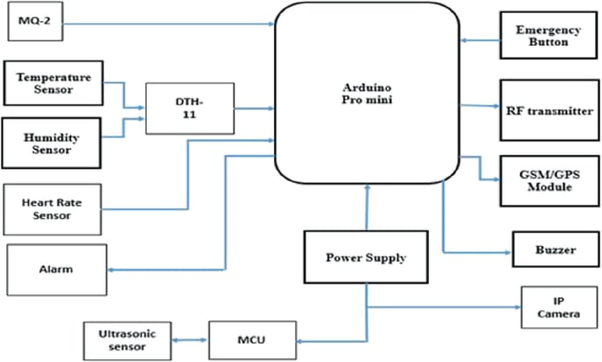

The diagram depicts a system architecture centered around an *Arduino Pro Mini* microcontroller, interfaced with various sensors and output modules. Here’s a breakdown of the components and their connections:

1. *Sensors & Inputs*:
- *MQ-2*: gas/smoke sensor connected directly to the Arduino.
- *DHT-11*: temperature & humidity sensor feeding data to the Arduino.
- *Heart Rate Sensor*: linked to the Arduino for biometric monitoring.
- *Alarm*: an output device controlled by the Arduino.
- *Ultrasonic Sensor*: connected to a separate MCU (Microcontroller Unit) which then interfaces with the Arduino.
- *Emergency Button*: input to the Arduino for emergency signaling.

2. *Processing & Control*:
- *Arduino Pro Mini*: the central microcontroller managing all sensor inputs and output commands.
- *MCU*: a secondary microcontroller handling the ultrasonic sensor data and passing it to the Arduino.

3. *Output & Communication Modules*:
- *RF transmitter*: for wireless data transmission.
- *GSM/GPS Module*: enables cellular communication and location tracking.
- *Buzzer*: audio alert device driven by the Arduino.
- *IP Camera*: connected via the power supply line, likely for surveillance.

4. *Power*:
- *Power Supply*: provides energy to the Arduino and associated peripherals (buzzer, IP camera).

The system appears to be an integrated safety/monitoring setup, combining environmental sensing (gas, temperature, humidity), health monitoring (heart rate), security (ultrasonic sensor, IP camera, emergency button), and communication (RF, GSM/GPS).
Decimation is a digital signal processing technique that reduces a signal's sampling rate by selecting every Dth sample, where D is the downsampling factor. This process can lead to aliasing if not preceded by appropriate filtering.
- *Downsampling Factor (D)*: Controls the reduction in sampling rate.
- *Filtering*: Often applied before decimation to mitigate aliasing, typically using low-pass filters.
- *Applications*: Common in signal processing for reducing data rates, improving computational efficiency, and adapting signals for different processing or transmission requirements.
2.2 WORKING PRINCIPLE:
The smart industrial safety helmet is an advanced safety system designed to protect workers by continuously monitoring both environmental conditions and the physical status of the user. It operates based on the concept of the Internet of Things (IoT), where sensors, microcontrollers, and communication modules work together to provide real-time safety monitoring and alerts.
The working of the smart helmet begins with the sensing unit. Various sensors are embedded in the helmet to detect different parameters. A gas sensor is used to identify the presence of harmful gases such as carbon monoxide, methane, and LPG in the industrial environment. At the same time, a temperature sensor measures the surrounding temperature to ensure that it remains within safe limits. An accelerometer is used to monitor sudden movements, tilts, or falls, which helps in detecting accidents. Additionally, a helmet detection sensor ensures that the worker is properly wearing the helmet before entering hazardous areas.
All the data collected from these sensors is continuously sent to a microcontroller, such as an Arduino or ESP32, which acts as the brain of the system. The microcontroller processes the incoming data and compares it with predefined threshold values. These threshold values represent safe working conditions, and any deviation from them indicates a potential risk or hazard.
When the system detects abnormal conditions, such as high gas concentration, excessive temperature, or a sudden fall, the microcontroller immediately activates the alert system. This alert system may include a buzzer, LED indicators, or vibration motors to notify the worker instantly. These alerts are especially useful in noisy industrial environments where audio warnings alone may not be sufficient.
In addition to local alerts, the helmet is equipped with a communication module such as GSM, Wi-Fi, or Bluetooth. This module enables the system to send real-time notifications to supervisors or control rooms. The transmitted information may include details about the detected hazard, the condition of the worker, and the location if a GPS module is integrated. This ensures that necessary action can be taken quickly in case of emergencies.
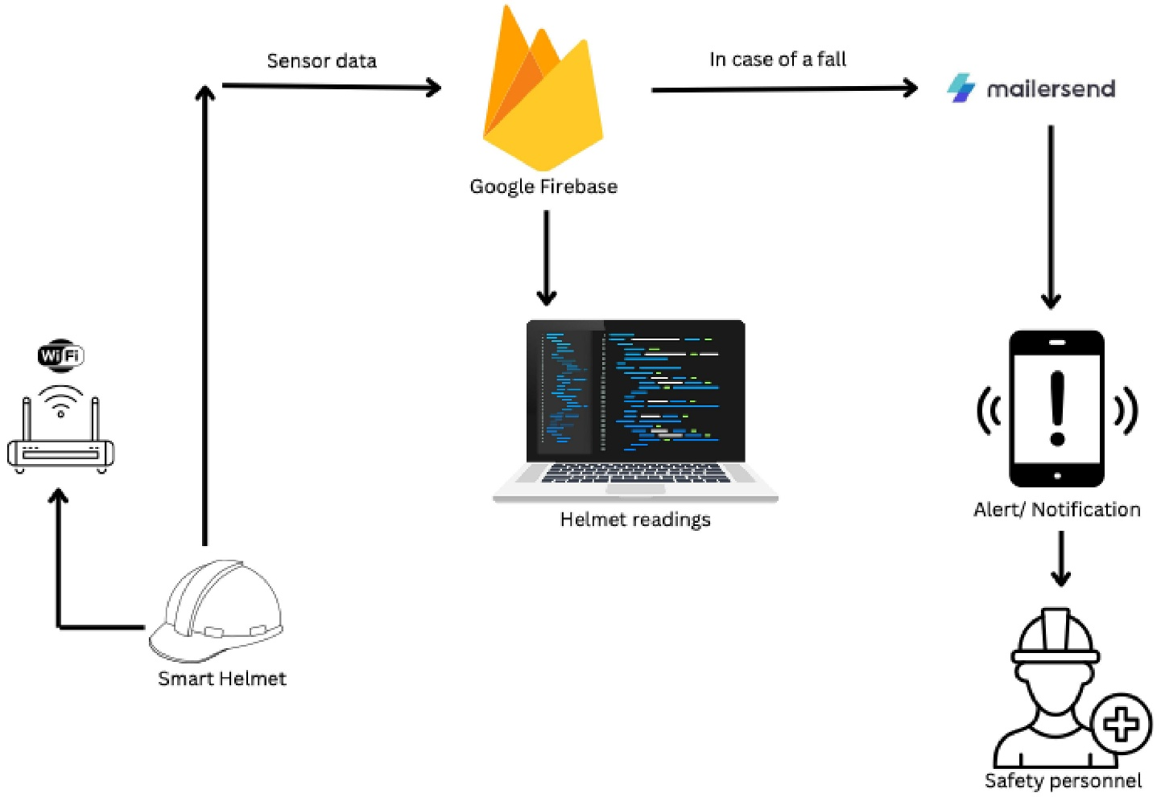
The system also supports real-time monitoring through IoT platforms. Data collected from the helmet can be uploaded to cloud servers, allowing supervisors to monitor multiple workers simultaneously using mobile applications or web dashboards. This improves overall safety management in industrial environments.
The entire system is powered by a rechargeable battery, which is designed to provide sufficient backup for long working hours. Efficient power management techniques are used to ensure continuous operation without frequent interruptions.
In conclusion, the smart industrial safety helmet works by integrating sensing, processing, alerting, and communication technologies into a single wearable device. It not only provides physical protection but also actively detects hazards and ensures timely response, thereby significantly improving worker safety and reducing the risk of accidents in industrial settings
The smart industrial safety helmet operates using an integrated system of sensors, processing units, and communication modules. The above block diagram represents the overall architecture of the system.
The working of the smart industrial safety helmet starts with the sensing stage. Various sensors are embedded inside the helmet to continuously monitor environmental conditions and the worker’s status. A gas sensor detects harmful gases present in the surroundings, while a temperature sensor measures the ambient temperature. An accelerometer is used to detect sudden movements or falls, which helps in identifying accidents. In addition, a helmet detection sensor ensures that the worker is wearing the helmet properly before entering hazardous zones.
All the sensor data is transmitted to a microcontroller such as Arduino or ESP32, which acts as the central processing unit of the system. The microcontroller continuously reads the data from all sensors and compares it with predefined threshold values. These threshold values represent safe operating conditions, and any deviation indicates a potential risk.
If the sensed values exceed safe limits, the system immediately moves to the alert stage. A buzzer or LED indicator is activated to warn the worker about the danger. In noisy industrial environments, vibration alerts can also be used to ensure the warning is noticed.
Along with local alerts, the system also uses a communication module such as GSM, Wi-Fi, or Bluetooth to send notifications to supervisors or control rooms. These messages may include details about the detected hazard and the worker’s condition. If a GPS module is integrated, the exact location of the worker can also be shared, enabling quick emergency response.
The helmet also supports IoT-based monitoring. The collected data can be uploaded to a cloud platform, allowing real-time monitoring through mobile applications or web dashboards. This helps industries track the safety status of multiple workers simultaneously.
The entire system is powered by a rechargeable battery, ensuring portability and continuous operation. Power management techniques are used to maximize battery life.

2.3 ARCHITECTURE
The architecture of a smart industrial safety helmet is designed as an integrated system that combines sensing, processing, communication, and monitoring units to ensure the safety of industrial workers. This system follows a layered approach where each component performs a specific function, and all components work together to provide real-time hazard detection and alerts.
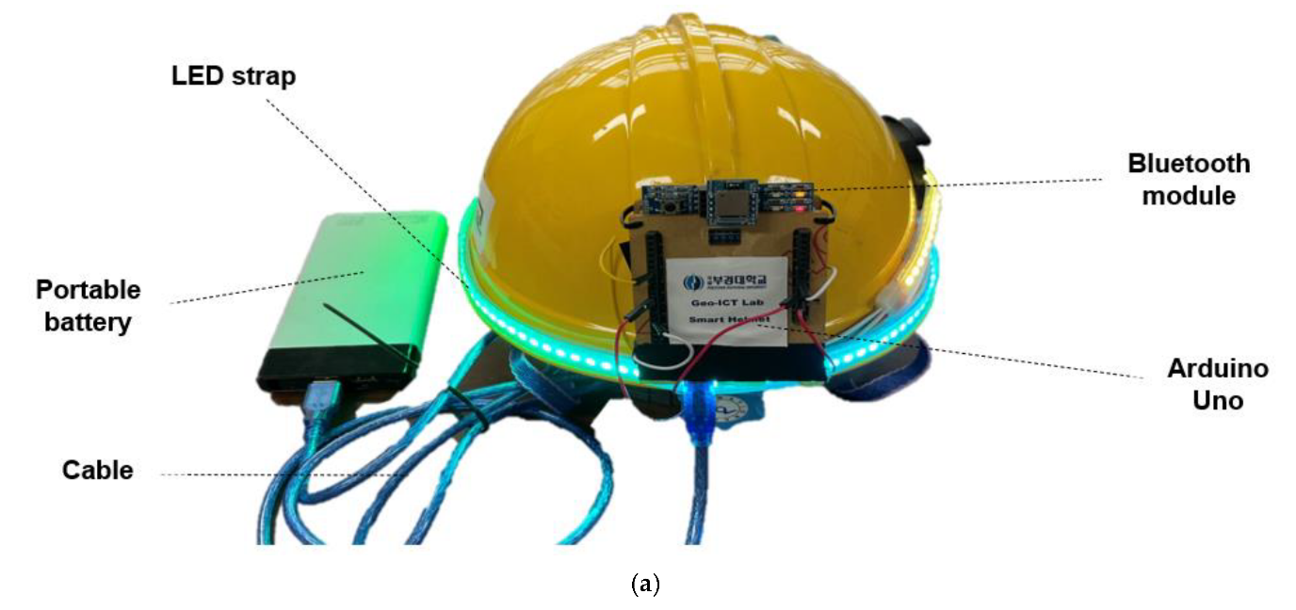
At the first level, the sensing unit plays a crucial role in collecting data from the environment and the worker. Various sensors such as gas sensors, temperature sensors, accelerometers, and helmet detection sensors are embedded within the helmet. These sensors continuously monitor parameters like toxic gas levels, surrounding temperature, sudden movements, and whether the helmet is properly worn. The data collected by these sensors is essential for identifying unsafe conditions in industrial environments.
The collected data is then transmitted to the processing unit, which consists of a microcontroller such as Arduino or ESP32. This unit acts as the brain of the system. It continuously reads the sensor values and compares them with predefined threshold limits. Based on this comparison, the microcontroller makes decisions regarding the safety status of the worker. If all values are within safe limits, the system continues normal monitoring. However, if any abnormal condition is detected, such as high gas concentration, excessive temperature, or a fall, the system immediately initiates safety measures.
The next part of the architecture is the alert and communication unit. When a dangerous situation is detected, the system activates alert mechanisms such as buzzers, LEDs, or vibration motors to warn the worker instantly. At the same time, a communication module like GSM, Wi-Fi, or Bluetooth sends notifications to supervisors or control rooms. These notifications may include details about the hazard and the condition of the worker. If a GPS module is included, the exact location of the worker can also be shared, which helps in providing quick emergency assistance.
In addition to local alerts and communication, the system also supports an application or cloud layer. The data from the helmet can be uploaded to cloud platforms, allowing real-time monitoring through mobile applications or web dashboards. This enables supervisors to track multiple workers simultaneously and take necessary actions when required.
The entire system is powered by a rechargeable battery, which ensures portability and uninterrupted operation. Proper power management techniques are used to optimize battery usage and extend working time.
In conclusion, the architecture of the smart industrial safety helmet is a well-structured system that integrates multiple technologies into a single wearable device. It ensures continuous monitoring, quick detection of hazards, and immediate communication, thereby significantly improving safety in industrial environments.

CHAPTER 4

HARDWARE COMPONENTS
Circuit diagram of our project comprises of following modules

4.1 Arduino uno
The Arduino Uno is a popular, open-source microcontroller board based on the ATmega328P chip, designed for beginners and professionals to create interactive projects. Released in 2010, it features 14 digital I/O pins (6 PWM capable), 6 analog inputs, a 16 MHz ceramic resonator, and a USB connection for programming. It operates at 5V, typically powered via USB or a 7-12V power jack. It is widely used for DIY electronics, robotics, and automation due to its ease of use, extensive libraries, and free Arduino IDE coding environment. The R3 is the most common version.

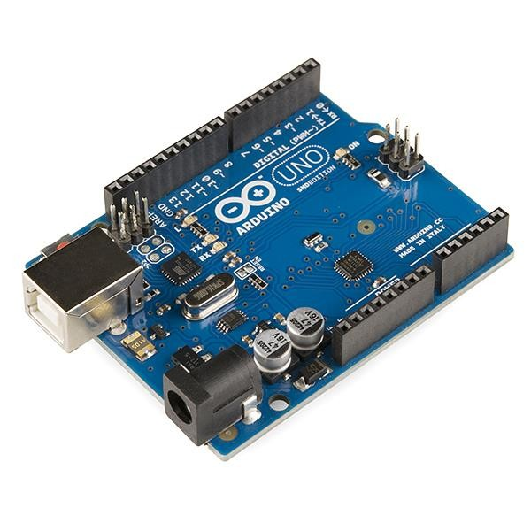
Fig 3.7 Arduino uno
Arduino boards have different types of pins that allow interaction with electronic components.
Digital pins (D0–D13) can function as inputs to read signals or outputs to control devices like LEDs, and some support PWM (~) for analog-like control, such as adjusting LED brightness or motor speed. Analog pins (A0–A5) read variable signals from sensors and convert them into digital values using an ADC. Power pins provide necessary voltage, including 5V, 3.3V, GND, and VIN for external power connections. Additionally, Arduino includes special function pins like RX and TX for serial communication, AREF for analog reference voltage, and a Reset pin to restart the board. Understanding these pins is essential for projects like Morse code-based Li-Fi, where LEDs are driven via output pins and photodiodes or LDRs serve as inputs to detect light signals accurately.

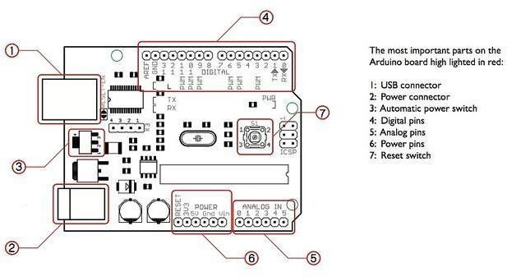
Fig Arduino uno pin daigram
4.2 Gas Sensor
Diagram of Gas Sensor

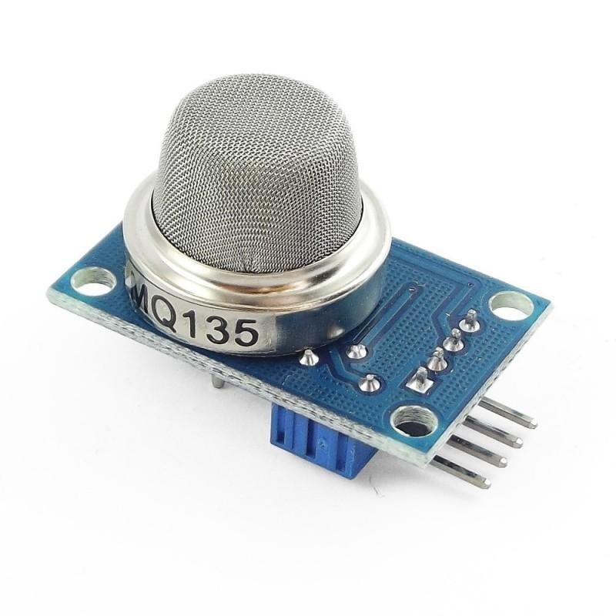
A gas sensor is one of the most important components used in a smart industrial safety helmet. It is responsible for detecting the presence of harmful or toxic gases in the surrounding environment. In industries such as mining, chemical plants, and oil refineries, gases like carbon monoxide, methane, LPG, and smoke can be dangerous to workers. The gas sensor helps in identifying these hazards at an early stage.
The commonly used gas sensors in such systems belong to the MQ series, such as MQ-2, MQ-135, or MQ-7. These sensors are sensitive to different types of gases and are widely used due to their low cost and reliability. The sensor consists of a sensing element and a heating element. The heating element maintains a specific temperature required for the sensor to operate properly.
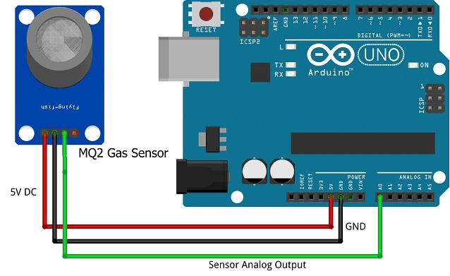
The working of a gas sensor is based on the change in resistance of the sensing material when exposed to gases. The sensing material, usually made of tin dioxide (SnO₂), reacts with gases present in the air.
- In clean air, the sensor has a certain resistance
- When harmful gases are present, the resistance changes
- This change is converted into an electrical signal
The sensor produces an analog output voltage proportional to the concentration of gas present in the environment. This output is then sent to the microcontroller (Arduino/ESP32) for processing.
A gas sensor is a critical component in a smart industrial safety helmet, designed to continuously monitor the presence of harmful gases in industrial environments. Industries such as mining, petroleum, chemical processing, and manufacturing often release toxic and flammable gases that are not visible to human senses. Exposure to such gases can lead to severe health issues, explosions, or even loss of life. Therefore, integrating a gas sensor into the safety helmet significantly enhances worker protection by providing early detection and warning.
The most commonly used gas sensors in such applications are from the MQ series, including MQ-2, MQ-7, and MQ-135. Each of these sensors is designed to detect specific gases or a range of gases. For example, MQ-2 is sensitive to LPG, methane, and smoke, while MQ-7 is mainly used for carbon monoxide detection. MQ-135 is suitable for detecting air quality and gases like ammonia, benzene, and CO₂. These sensors are widely preferred due to their affordability, durability, and ease of integration with microcontrollers.
4.3 Temperature Sensor

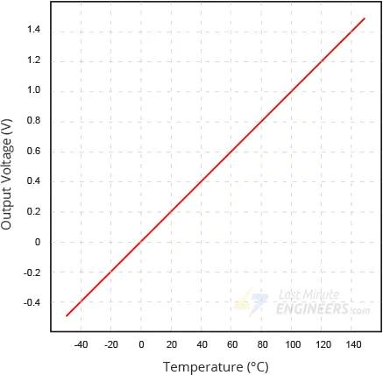

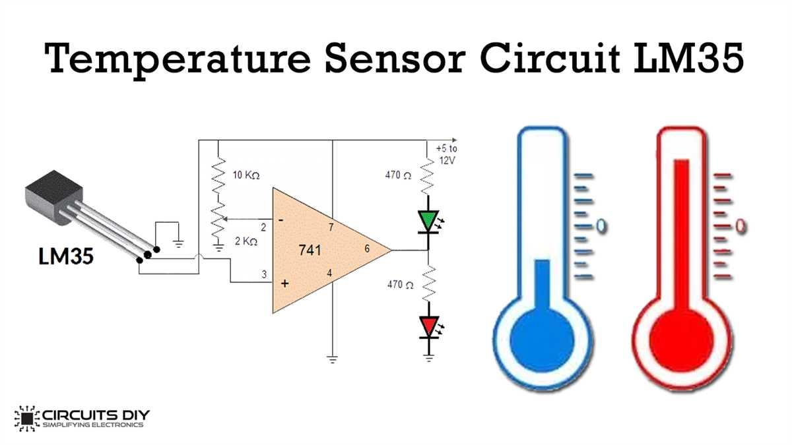

A temperature sensor is an essential component in a smart industrial safety helmet, used to continuously monitor the surrounding temperature of the worker. In industrial environments such as factories, mines, and chemical plants, temperature can rise to dangerous levels due to machinery, chemical reactions, or fire hazards. Excessive heat can lead to equipment failure, fire accidents, or serious health issues like heat stress and burns. Therefore, integrating a temperature sensor into the helmet helps in early detection of abnormal temperature conditions and ensures worker safety.
Commonly used temperature sensors in such systems include LM35 and DHT11. The LM35 is an analog temperature sensor that provides output voltage proportional to temperature, while the DHT11 is a digital sensor that measures both temperature and humidity. These sensors are widely used due to their simplicity, low cost, and reliable performance.
LM35 Temperature Sensor
The LM35 operates based on the principle that the output voltage is directly proportional to the temperature in degrees Celsius.
- It produces an output of 10 mV per °C
- For example:
  - 25°C → 250 mV
  - 40°C → 400 mV
$$V_{out}=10×T (mV)$$
The sensor does not require any external calibration and provides accurate readings over a wide temperature range. It senses temperature through a semiconductor material whose electrical properties change with temperature.
The temperature sensor in a smart industrial safety helmet is not just a measuring device but a critical safety component that ensures the worker operates within safe thermal conditions. Industrial environments often experience rapid temperature changes due to heavy machinery, electrical faults, chemical reactions, or fire hazards. Continuous monitoring of temperature helps in preventing accidents and maintaining a safe working environment.
The sensor is strategically placed in the helmet to measure the ambient temperature near the worker’s head, which is one of the most sensitive parts of the body. This allows the system to detect even small variations in temperature that could indicate a potential hazard.
Semiconductor-Based Sensing (LM35)
The LM35 operates using semiconductor technology. It contains integrated circuits that sense temperature through the change in voltage across a diode-like structure.
- As temperature increases, the voltage across the sensor increases linearly
- The relationship is precise and calibrated in degrees Celsius
- No external calibration is required
$$T(^{∘}C)=\frac{V_{out}(mV)}{10}$$
This linear behavior makes it very easy for microcontrollers to interpret the data accurately.
4.4 Accelerometer(ADXL335)

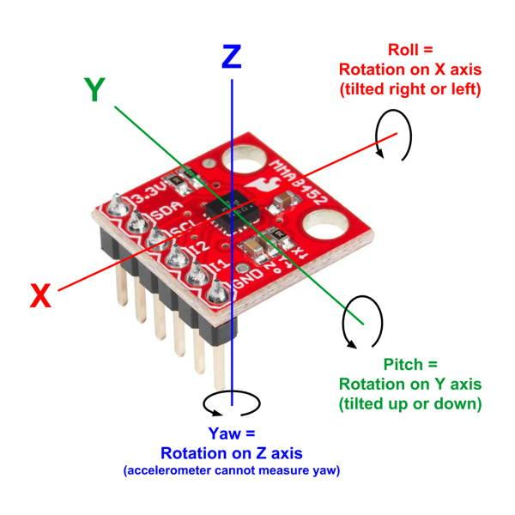
An accelerometer is a key component in a smart industrial safety helmet, used to detect motion, orientation, and sudden impacts. In industrial environments, workers are at risk of accidents such as slips, falls, or collisions. The accelerometer helps in identifying these events instantly by measuring changes in motion and acceleration. This enables the system to provide immediate alerts and emergency responses, thereby improving worker safety.
The most commonly used accelerometer in such applications is the ADXL335, which is a 3-axis accelerometer capable of measuring acceleration along the X, Y, and Z axes. It is widely used due to its compact size, low power consumption, and high sensitivity.

The accelerometer works based on MEMS (Micro-Electro-Mechanical Systems) technology. Inside the sensor, a small mass is suspended by tiny springs. When the helmet moves, tilts, or experiences a sudden impact, this mass shifts from its original position. This movement causes a change in electrical properties such as capacitance or voltage, which is then converted into an electrical signal.
These signals are sent to the microcontroller, such as Arduino or ESP32, where they are continuously monitored and analyzed. Under normal conditions, the sensor outputs stable values that correspond to regular movements. However, during a fall or sudden impact, there is a sharp change in the acceleration values. The microcontroller detects this abnormal change and identifies it as a possible accident.
Once a fall or abnormal motion is detected, the system activates safety mechanisms. A buzzer or alert is triggered to notify the worker, and a message is sent to the supervisor through a communication module like GSM or Wi-Fi. If a GPS module is included, the location of the worker can also be shared for quick assistance.
The accelerometer also helps in detecting the orientation of the helmet. For example, if the helmet is tilted for a long time after a fall, it indicates that the worker may be unconscious or injured. This additional information improves the accuracy of accident detection.
In conclusion, the accelerometer is a vital sensor in the smart industrial safety helmet. It continuously monitors motion and detects sudden changes, enabling quick identification of accidents. By providing real-time alerts and supporting emergency response, it significantly enhances worker safety in hazardous industrial environments.
To provide a comprehensive description of an accelerometer beyond simple bullet points, we must examine the interplay between classical mechanics and modern electrical engineering.
At its core, an accelerometer is a transducer that converts mechanical force into an electrical signal. It operates on the principle of a damped mass on a spring. When the device experiences acceleration, the "proof mass" (an internal known mass) resists this change in motion due to inertia. This resistance causes the mass to displace relative to the device's outer casing. By measuring this displacement, the device calculates the exact magnitude and direction of the force being applied.
In a stationary state on Earth, an accelerometer does not measure zero; instead, it measures the upward force exerted by the ground that prevents it from falling. This is why a vertical accelerometer reads $1g$ (standard gravity) when sitting still. To achieve a "true" zero reading, the device would need to be in a state of freefall.
4.5 Bluetooth
Diagram of Bluetooth Module

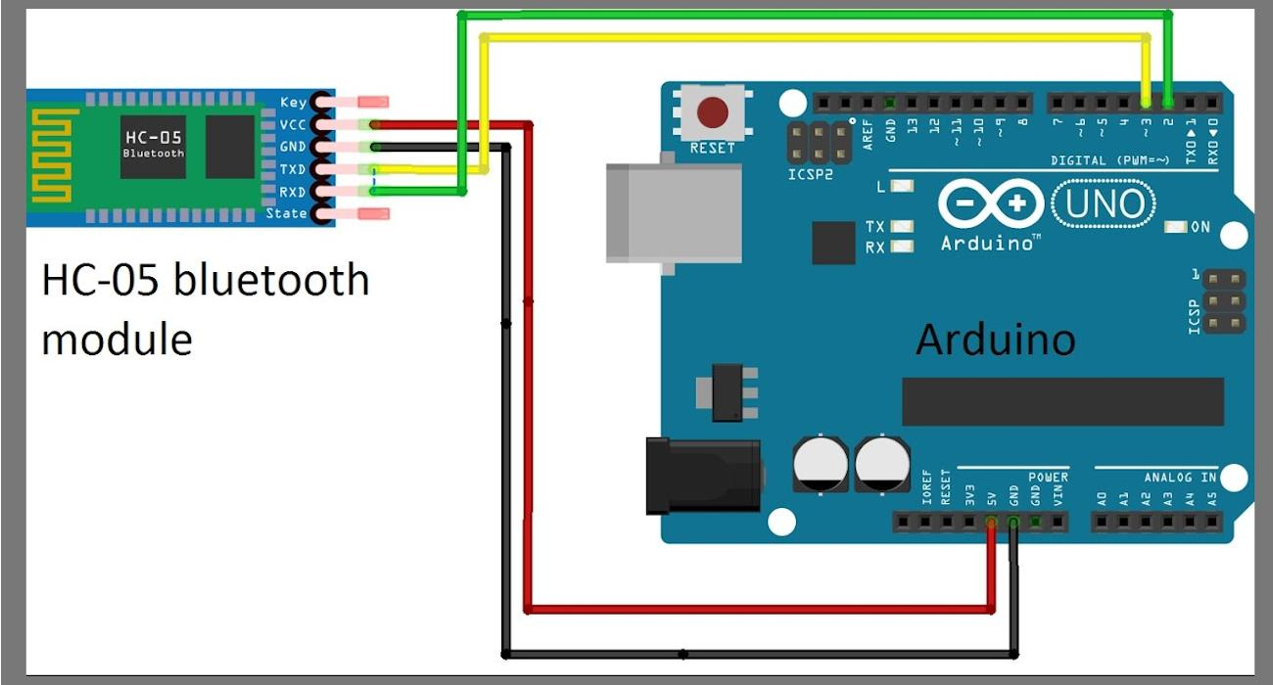

Detailed Description
A Bluetooth module is a short-range wireless communication device used in a smart industrial safety helmet to transfer data between the helmet and external devices such as smartphones, tablets, or monitoring systems. It enables wireless communication without the need for physical cables, making the system more flexible, portable, and easy to use in industrial environments.
The commonly used Bluetooth module in embedded systems is the HC-05 or HC-06 module. These modules are cost-effective, easy to interface with microcontrollers like Arduino or ESP32, and widely used in IoT-based projects. The Bluetooth module operates in the 2.4 GHz frequency band and provides reliable wireless communication within a limited range, typically around 10 to 100 meters depending on the environment.

Working Principle
The Bluetooth module works based on wireless serial communication (UART protocol). It acts as a bridge between the microcontroller and external devices.
- The microcontroller sends data through TX (Transmit pin)
- The Bluetooth module transmits this data wirelessly
- The receiving device (smartphone or system) receives data via Bluetooth
- Similarly, commands can be sent back from the mobile device to the helmet
This two-way communication allows real-time data exchange.

Integration with Smart Helmet
In the smart industrial safety helmet system, Bluetooth is used for:
- Transmitting sensor data (gas, temperature, fall detection)
- Sending alerts to a nearby smartphone
- Monitoring worker status in real time
- Testing and debugging the system during development
- Sending manual commands to control the system
For example, when a hazard is detected, the helmet can send an alert directly to a mobile app via Bluetooth.
4.6 Power Supply
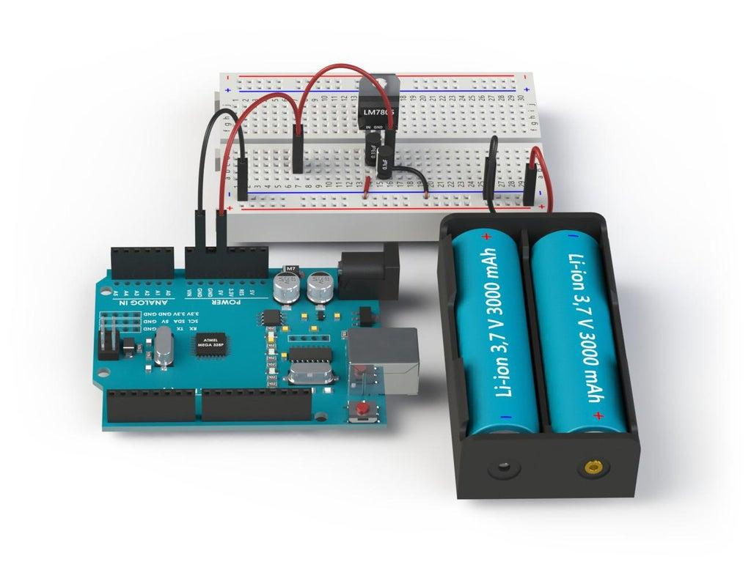
A 5V power supply is a fundamental component in a smart industrial safety helmet system, as it provides the required electrical energy to operate all electronic modules such as sensors, microcontroller, communication modules, and alert systems. Since the system is wearable and portable, a stable and regulated power source is essential for continuous and reliable operation in industrial environments.
Most components used in the smart helmet, such as Arduino, gas sensors, temperature sensors, accelerometers, GPS modules, and Bluetooth modules, operate efficiently at 5V. Therefore, a regulated 5V power supply ensures that all components receive a constant voltage without fluctuations, which helps in improving system stability and accuracy.
Working Principle
The 5V power supply works by converting an unregulated input source into a stable 5V DC output. The input source can be a rechargeable battery or a higher DC voltage source. The conversion process typically involves regulation using a voltage regulator such as the 7805 IC or a DC-DC buck converter.
The working process includes:
- Input Stage:
A battery (such as 7.4V or 9V) provides the initial power supply.
- Regulation Stage:
The voltage regulator reduces and stabilizes the voltage to a constant 5V level.
- Filtering Stage:
Capacitors are used to remove noise and smooth the output voltage.
- Output Stage:
A stable 5V DC supply is delivered to all connected components.
- Role in Smart Helmet System
The 5V power supply plays a critical role in the functioning of the smart industrial safety helmet:
- Powers microcontroller (Arduino/ESP32)
- Supplies energy to sensors (gas, temperature, accelerometer)
- Operates communication modules (GPS, GSM, Bluetooth)
- Drives alert systems like buzzer and LED indicators
- Ensures continuous real-time monitoring
Without a stable power supply, the system may malfunction or provide incorrect sensor readings.
4.7 Buzzer
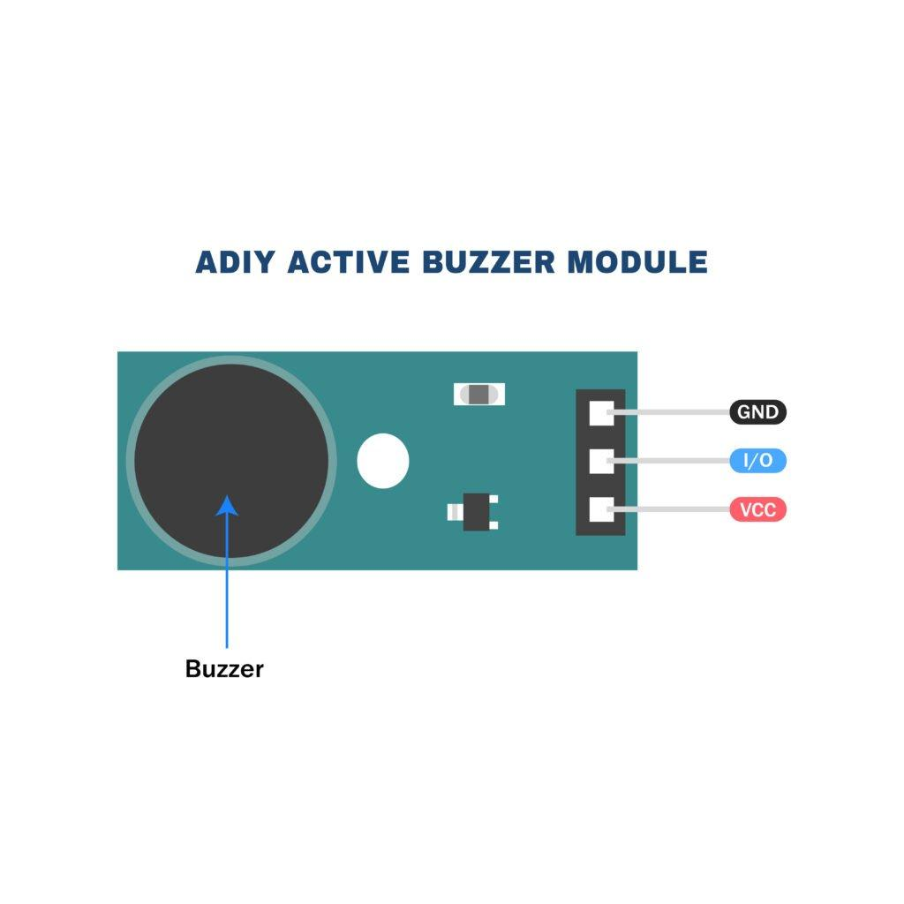
A buzzer is an important alerting component used in a smart industrial safety helmet to provide immediate audio warnings during hazardous situations. In industrial environments, workers may not always notice visual indicators like LEDs, especially in noisy surroundings. Therefore, a buzzer is used to generate a loud sound signal that quickly grabs attention and alerts the worker about danger.
The buzzer is typically an active buzzer or piezoelectric buzzer, which is compact, low power, and easy to integrate with microcontrollers such as Arduino or ESP32. It plays a crucial role in the safety system by acting as the first line of alert when unsafe conditions are detected.
Role in Smart Helmet System
In the smart industrial safety helmet, the buzzer is used to:
- Alert workers when gas levels are dangerous
- Warn about high temperature conditions
- Indicate fall or accident detection
- Notify when helmet is not properly worn
Provide continuous warning until the issue is resolved
An audio signaling device like a beeper or buzzer may be electromechanical or piezoelectric or mechanical type. The main function of this is to convert the signal from audio to sound. Generally, it is powered through DC voltage and used in timers, alarm devices, printers, alarms, computers, etc. Based on the various designs, it can generate different sounds like alarm, music, bell & siren.
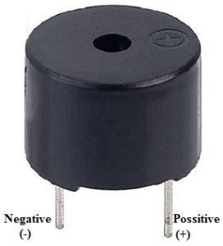
fig.3.10 Buzzer
The pin configuration of the buzzer is shown below. It includes two pins namely positive and negative. The positive terminal of this is represented with the ‘+’ symbol or a longer terminal. This terminal is powered through 6Volts whereas the negative terminal is represented with the ‘-‘symbol or short terminal and it is connected to the GND terminal.
SOFTWARE COMPONENTS
4.8 Using OfflineIDE2.x

The Arduino Integrated Development atmosphere - or Arduino computer code (IDE) - contains a text editor for writing code, a message space, a text console, a toolbar with buttons for common functions and a series of menus. It connects to the Arduino and Genuino hardware to transfer programs and communicate with them. Programs written victimization Arduino computer code (IDE) area unit area unit. These sketches area unit written within the text editor and area unit saved with the file extension .ino. The editor has options for cutting/pasting and for searching/replacing text. The message space provides feedback whereas saving and commerce and conjointly displays errors. The console displays text output by the Arduino computer code (IDE), including complete error messages and other information. The bottom righthand corner of the window displays the configured board and serial port. The toolbar buttons allow you to verify and upload programs, create, open, and save sketches, and open the serial monitor. Before uploading your sketch, you need to select the correct items from the Tools > Board and Tools > Port menus. The boards are described below. On the Mac, the serial port is probably something like /dev/tty.usbmodem241 (for an Uno or Mega2560 or Leonardo) or /dev/tty.usbserial-1B1 (for a Duemilanove or earlier USB board), or /dev/tty.USA19QW1b1P1.1 (for a serial board connected with a the Keyspan USB-to-Serial adapter). On Windows, it's probably COM1 or COM2 (for a serial board) or COM4, COM5, COM7, or higher (for a USB board) - to find out, you look for USB serial device in the ports section of Windows Device Manager.
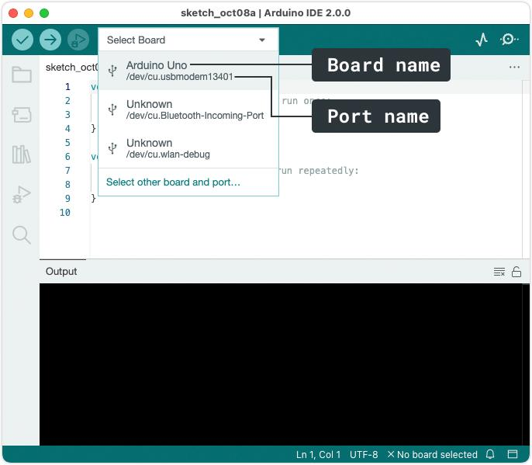
On Linux, it should 42 be /dev/ttyACMx , /dev/ttyUSBx or similar. Once you've selected the correct serial port and board, press the upload button in the toolbar or select the Upload item from the Sketch menu. Current Arduino boards will reset automatically and begin the upload. With older boards (pre-Diecimila) that lack auto-reset, you'll need to press the reset button on the board just before starting the upload. On most boards, you'll see the RX and TX LEDs blink as the sketch is uploaded. The Arduino Software (IDE) will display a message when the upload is complete, or show an error. When you transfer a sketch, you are victimization the Arduino bootloader, atiny low program that has been loaded on to the microcontroller on your board. It permits you to transfer code while not victimization any further hardware. The bootloader is active for a couple of seconds once the board resets; then it starts whichever sketch was last uploaded to the microcontroller. The bootloader can blink the on-board (pin 13) semiconductor diode once it starts (i.e. once the board resets). 5.2 PROGRAMMING LANGUAGE Embedded C is a collection of language extensions for the C programming language by the C Standards Committee to deal with commonality problems that exist between C extensions for different embedded systems. Embedded C is a collection of language extensions for the C programming language by the C Standards Committee to address commonality problems that exist between C extensions for different embedded systems. traditionally, embedded C programming needs nonstandard extensions to the C language so as to support exotic options such as fixed-point arithmetic, multiple distinct memory banks, and basic I/O operations. An embedded system is a computer system with a dedicated function within a larger mechanical or electrical system, often with real-time computing constraints. It is embedded as part of a complete device often including hardware and mechanical parts. Embedded systems control many devices in 43 common use today. Ninety-eight percent of all microprocessors are manufactured as components of embedded systems. Examples of properties of typical embedded computers compared with general counterparts area unit low power consumption, small size, rugged operative ranges, and low per-unit price. This comes at the value of restricted process resources, that build them considerably tougher to program and to act with. However, by building intelligence mechanisms on prime of the hardware, taking advantage of doable existing sensors and also the existence of a network of embedded. Modern embedded systems area unit typically based mostly on microcontrollers (i.e. CPU's with integrated memory or peripheral interfaces), however standard microprocessors (using external chips for memory and peripheral interface circuits) also are common, particularly in more-complex systems. Since the embedded system is dedicated to specific tasks, design engineers can optimize it to reduce the size and cost of the product and increase the reliability and performance. Some embedded systems are mass-produced, benefiting from economies of scale. Embedded systems range from portable devices such as digital watches and MP3 players, to large stationary installations like traffic lights, factory controllers, and largely complex systems like hybrid vehicles, MRI, and avionics. Complexity varies from low, with a single microcontroller chip, to very high with multiple units, peripherals and networks mounted inside a large chassis or enclosure. 5.3 INTERNET OF THINGS (IoT) The Internet of things (IoT) describes the network of physical objects “things” that area unit embedded with sensors, software, and different technologies for the aim of connecting and exchanging information with different devices and systems over the web. 44 Things have evolved thanks to the convergence of multiple technologies, period of time analytics, machine learning, trade goods sensors, and embedded systems. ancient fields of embedded systems, wireless device networks, management systems, automation (including home and building automation), et al all contribute to enabling the web of things. The IoT is that the strategy for gadgets that case hardware, and network, that allows these devices to repair, act along and switch data. IoT incorporates broadening web helpful than normal gadgets, as an example, work areas to any call of typically non internet get to material gadgets and on on a daily basis by day supply objects. Inserted through innovation, these gadgets will banter and coordinate over the web, and that they is a bit checked and restricted. The IoT is the strategy for gadgets that encase hardware, and network, which enables these devices to fix, act together and switch information. IoT incorporates broadening Internet beneficial than standard gadgets, for example, work areas to any decision of generally non web get to material gadgets and on a day by day source objects. Inserted through innovation, these gadgets can banter and coordinate over the Internet, and they can be a little checked and restricted. Fig. 5.1: IOT in Health care

CHAPTER 5

RESULTS AND ANALYSIS
The smart industrial safety helmet project was successfully implemented and tested to ensure real-time monitoring of industrial working conditions. The system integrates sensors such as gas sensor, temperature sensor, and accelerometer along with a microcontroller and communication modules. It is designed to continuously observe the environment and detect any unsafe conditions that may cause harm to workers.
During the operation, the system was able to accurately detect hazardous situations such as the presence of harmful gases, abnormal increase in temperature, and sudden falls or impacts. When any of these unsafe conditions were identified, the microcontroller immediately processed the sensor data and activated the alert system. The buzzer produced a loud sound to warn the worker instantly, ensuring quick attention to danger.
In addition to local alerts, the system also successfully transmitted notifications through communication modules like GSM or Bluetooth, depending on the setup. This allowed supervisors or control rooms to receive real-time updates about the worker’s condition and location, enabling fast emergency response.
The analysis of the system shows that it responds quickly and effectively to all detected hazards. The sensor readings were stable and reliable under normal conditions, and abnormal values were correctly identified when safety limits were exceeded. The system maintained continuous monitoring without interruption, demonstrating good stability and efficiency.
Overall, the smart industrial safety helmet proved to be a reliable and effective safety solution for industrial environments. It enhances worker safety by providing continuous monitoring, immediate alerts, and real-time communication, thereby reducing the risk of accidents and improving emergency response time.

CHAPTER 6

6.1APPLICATIONS
The smart industrial safety helmet has a wide range of applications in different industries where workers are exposed to hazardous environments. It improves safety by continuously monitoring environmental conditions, detecting accidents, and sending real-time alerts to workers and supervisors.
1. Construction Industry
In construction sites, workers face risks such as falling objects, unsafe structures, and extreme weather conditions. The smart helmet helps by detecting falls using the accelerometer and alerting workers instantly through a buzzer. It also monitors temperature and environmental conditions to prevent heat-related issues.
2. Mining Industry
Mining is one of the most dangerous industries due to toxic gases and underground working conditions. The gas sensor detects harmful gases like methane and carbon monoxide. The GPS module helps in locating workers during emergencies, making rescue operations faster and more effective.
3. Oil and Gas Industry
In oil refineries and gas plants, there is a high risk of gas leakage and fire accidents. The gas sensor continuously monitors the air and provides early warning alerts. This helps in preventing explosions and ensuring worker safety.
4. Chemical Industry
Chemical plants deal with toxic and hazardous substances. The smart helmet detects harmful gases and alerts workers before exposure becomes dangerous. This helps in reducing health risks and accidents caused by chemical leaks.
5. Manufacturing Industries
Factories and production units involve heavy machinery and high temperatures. The temperature sensor monitors heat levels, while the accelerometer detects accidents or falls. This ensures safe working conditions for employees.
6. Steel and Cement Industries
These industries involve extreme heat, dust, and heavy machinery. The helmet helps in monitoring temperature and environmental conditions, protecting workers from heat stress and respiratory issues.
7. Power Plants
Power generation plants have electrical risks and high-voltage equipment. The smart helmet helps in detecting unsafe conditions and alerts workers to avoid electrical hazards and overheating.
8. Construction of Tunnels and Underground Projects
Tunnel construction involves low visibility, confined spaces, and poor ventilation. The gas sensor detects toxic gases, and the system ensures continuous safety monitoring.
9. Emergency and Rescue Operations
Firefighters and rescue teams can use smart helmets to monitor environmental conditions and locate victims using GPS. This improves efficiency during disaster response.
10. Smart Industrial Automation
In modern industries (Industry 4.0), smart helmets are used for real-time worker monitoring, integrating IoT systems for centralized safety management and data analysis.

6.2ADVANTAGES AND DISADVANATGES
ADVANTAGES
The smart industrial safety helmet provides several important benefits that improve worker safety and industrial efficiency. It is designed to reduce accidents and ensure real-time monitoring in hazardous environments.
1. Real-Time Monitoring
The helmet continuously monitors environmental conditions such as gas levels, temperature, and motion, ensuring immediate detection of hazards.
2. Early Accident Detection
Using sensors like accelerometer and gas sensor, the system detects accidents, falls, and gas leaks at an early stage, reducing risk of serious injury.
3. Immediate Alert System
The buzzer and LED provide instant warnings to workers, helping them react quickly during dangerous situations.
4. Remote Communication
With GSM, Bluetooth, or Wi-Fi modules, alerts and data can be sent to supervisors or control rooms for quick emergency response.
5. Worker Location Tracking
GPS integration helps in tracking the exact location of workers, which is very useful during emergencies and rescue operations.
6. Improves Industrial Safety
It significantly reduces workplace accidents by continuously monitoring hazardous conditions.
7. IoT Based Monitoring
Data can be stored and monitored on cloud platforms, enabling smart industrial safety management.
8. Easy to Use
The system is simple, wearable, and does not require complex operation by workers.
9. Low Cost Implementation
Using components like Arduino and basic sensors makes the system affordable.
10. Portable and Compact
All components are integrated into a helmet, making it easy to carry and use in any industrial environment.

Disadvantages of Smart Industrial Safety Helmet
Despite its advantages, the smart industrial safety helmet also has some limitations that affect its performance in certain conditions.
1. Limited Battery Life
The system depends on a battery, which requires frequent charging for continuous operation.
2. Sensor Accuracy Issues
Sensors like gas and temperature sensors may give slightly inaccurate readings in extreme environmental conditions.
3. Limited Communication Range (Bluetooth)
If Bluetooth is used, the communication range is short and not suitable for large industrial areas.
4. High Dependency on Electronics
If any electronic component fails, the entire system may stop working.
5. Environmental Interference
Dust, humidity, and extreme temperatures can affect sensor performance.
6. Maintenance Required
Regular calibration and maintenance of sensors are required for accurate results.
7. Initial Setup Complexity
Integration of multiple sensors and modules can be slightly complex for beginners.
8. False Alerts
Sudden movements or vibrations may sometimes trigger incorrect alerts.
9. Cost Increase with Advanced Modules
Adding GPS, GSM, and IoT features increases the overall cost of the system.
10. Not Fully Autonomous
Human intervention is still required for maintenance, charging, and system monitoring.

6.3 CONCLUSION
The smart industrial safety helmet is an effective and innovative safety system designed to improve worker protection in industrial environments. It integrates various sensors such as gas sensors, temperature sensors, and accelerometers along with a microcontroller and communication modules to continuously monitor the working conditions in real time.
The system successfully detects hazardous situations such as gas leakage, abnormal temperature rise, and sudden falls or impacts. When any unsafe condition is identified, it immediately activates alert systems like a buzzer and LED indicators to warn the worker. In addition, it can send real-time notifications to supervisors or control rooms using GSM, Bluetooth, or Wi-Fi modules, ensuring quick emergency response.
The inclusion of GPS further enhances the system by providing accurate location tracking of workers during emergencies, which is highly useful for rescue operations. The IoT-based monitoring capability allows continuous supervision and improves overall industrial safety management.
Overall, the smart industrial safety helmet provides a reliable, cost-effective, and efficient solution for preventing accidents and ensuring worker safety. It significantly reduces risks in hazardous environments by enabling real-time monitoring, early detection of dangers, and immediate alert generation. Therefore, it is a highly useful system for modern industrial safety applications and contributes to the development of smart and safe working environments.
The smart industrial safety helmet is a modern safety system designed to enhance protection and reduce accidents in hazardous industrial environments. It integrates multiple technologies such as sensors, microcontrollers, and communication modules to continuously monitor the safety conditions of workers in real time.
The system effectively detects dangerous situations such as the presence of toxic gases, abnormal temperature rise, sudden falls, or impact conditions using sensors like gas sensors, temperature sensors, and accelerometers. These sensors continuously collect environmental and motion data and send it to the microcontroller for processing and analysis.
When any unsafe condition is detected, the system immediately activates alert mechanisms such as a buzzer and LED indicators to warn the worker instantly. At the same time, emergency notifications are sent to supervisors or control rooms through GSM, Bluetooth, or Wi-Fi modules. This ensures quick response and timely action during emergencies.
The addition of GPS tracking further improves the system by providing real-time location information of workers, which is highly useful during rescue operations in case of accidents. The IoT-based monitoring system allows remote supervision, making it easier to manage multiple workers in large industrial areas.
The smart helmet improves industrial safety by reducing response time, preventing accidents, and ensuring continuous monitoring of workers without manual supervision. It is cost-effective, portable, and easy to implement, making it suitable for a wide range of industries such as construction, mining, oil and gas, and manufacturing.
However, the system still depends on battery power and requires proper maintenance and calibration for accurate performance. Despite these limitations, the advantages such as real-time monitoring, early warning system, and emergency communication make it a highly reliable safety solution.
In conclusion, the smart industrial safety helmet plays a significant role in modern industrial safety systems. It enhances worker protection, improves emergency response, and contributes to the development of smart and safe industrial environments. It is a practical and efficient solution for preventing accidents and saving lives in hazardous working conditions.

CHAPTER 7

FUTURE SCOPE
1. Integration of Artificial Intelligence (AI)
In future systems, AI can be used to analyze sensor data such as gas levels, temperature changes, and motion patterns. The system can learn normal working behavior and detect abnormal conditions more accurately. This helps in predicting accidents before they occur, making the helmet more intelligent and proactive.
2. Machine Learning-Based Accident Prediction
Machine Learning algorithms can be trained using past accident data to identify risk patterns. For example, unusual body movements or repeated exposure to high temperature can be recognized as danger signals. This will help in early warning and accident prevention rather than only detection.
3. Advanced Health Monitoring Sensors
Future helmets can include health-related sensors such as heart rate sensors, SpO2 sensors, and body temperature sensors. These will help monitor the physical condition of workers and detect fatigue, dehydration, or heat stress in real time.
4. 5G and Advanced IoT Communication
By using 5G technology, data transmission will become faster and more reliable with very low delay. This will allow real-time monitoring of thousands of workers in large industrial areas with improved accuracy and connectivity.
5. Cloud-Based Smart Monitoring System
Future systems can store all sensor data in cloud platforms for long-term analysis. Supervisors can monitor multiple workers through dashboards and receive alerts instantly. This also helps in maintaining safety records and improving industrial safety planning.
6. GPS with Geofencing Technology
Advanced GPS systems can include geofencing features. If a worker enters a restricted or hazardous zone, the system will automatically trigger alerts. This will help prevent unauthorized or unsafe entry into dangerous areas.
7. Energy Harvesting and Solar Power
Future helmets can be powered using solar panels or energy harvesting techniques (from movement or heat). This will reduce dependency on batteries and increase working time in remote industrial environments.
8. Augmented Reality (AR) Integration
AR technology can be integrated into helmets to display real-time information such as safety instructions, hazard warnings, and navigation paths directly in the worker’s view. This improves decision-making and situational awareness.
9. Drone-Based Emergency Support
In future developments, drones can be connected to the helmet system. When an accident is detected, drones can be automatically deployed to reach the location quickly and assist in rescue operations or provide live visuals to emergency teams.
10. Smart Industrial Network Integration
The helmet can be integrated into a complete industrial safety network where all machines, sensors, and workers are connected. This allows centralized monitoring and automated safety control systems for entire industries.

CHAPTER 8

REFERENCES
1. Kruger, C.P., and Hancke, G.P., "Implementing the Internet of Things vision in industrial wireless sensor networks," IEEE International Conference on Industrial Informatics (INDIN 2014), July 2014, pp. 627-632.
2. Kumar, A., and Hancke, G.P., "A Zigbee-Based Animal Health Monitoring System," IEEE Sensors Journal, Vol.15, No.1, Jan. 2015, pp. 610-617.
3. Kumar, A., and Hancke, G.P., "Energy Efficient Environment Monitoring System Based on the IEEE 802.15.4 Standard for Low Cost Requirements," IEEE Sensors Journal, Vol.14, No.8, August 2014, pp. 2557-2566.
4. Li, P., Meziane, R., Otis, M., Ezzaidi, H., and Cardou, P., "A Smart Safety Helmet using IMU and EEG sensors for worker fatigue detection," IEEE Int. Symposium on Robotic and Sensors Environments (ROSE 2014), 16-18 Oct. 2014, pp. 55-60.
5. Mohd Rasli, M., Madzhi, N.K., and Johari, J., "Smart helmet with sensors for accident prevention," Int. Conf. on Electrical, Electronics and System Engineering (ICEESE 2013), 4-5 Dec. 2013, pp. 21-26.
6. National Instruments Corporation, "Strain Gauge Measurement – A Tutorial," National Instruments Corporation, 2014.
7. Opperman, C.A., and Hancke, G.P., "Using NFC-enabled Phones for Remote Data Acquisition and Digital Control," In Proc. of IEEE Africon 2011, Sep. 2011.
8. Sadasivam, K. and Gupta, S., "Weighing scale design – measure signals accurately," EE Times Industrial Control, pp. 1 – 7, 2011.
9. Shabina, "Smart Helmet Using RF and WSN Technology for Underground Mines Safety," Int. Conf. Intelligent Computing Applications (ICICA 2014), 6-7 March 2014, pp. 305-309.

10. Hancke, G.P., Markantonakis, K. and Mayes, K.E., "Security Challenges for User-Oriented RFID Applications within the 'Internet of Things'," Journal of Internet Technology, Vol. 11, No. 3, May 2010.
12. Haque, M., "Surveillance on Self-report: A Trial of Health and Safety Monitoring in Occupational Settings," Occupational Medicine, Vol. 50, No. 3, 2000, pp. 182-184.
13. Hermanus, M.A., "Occupational health and safety in mining-status, new developments, and concerns," Journal of The South African Institute of Mining and Metallurgy, Vol. 107 No. 8, pp. 531-538.
14. Kruger, C.P., and Hancke, G.P., "Benchmarking Internet of things devices," IEEE International Conference on Industrial Informatics, July 2014, pp. 611-616.
15. Kruger, C.P., and Hancke, G.P., "Implementing the Internet of Things vision in industrial wireless sensor networks," IEEE International Conference on Industrial Informatics (INDIN 2014), July 2014, pp. 627-632.
16. Kumar, A., and Hancke, G.P., "A Zigbee-Based Animal Health Monitoring System," IEEE Sensors Journal, Vol.15, No.1, Jan. 2015, pp. 610-617.

